**LOGISTIC REGRESSION** is a supervised machine learning algorithm used for classification tasks where the goal is to predict the probability that an instance belongs to a given class or not. Logistic regression is used for binary classification where we use sigmoid function, that takes input as independent variables and produces a probability value between 0 and 1.

**Key Concepts:**

* Logistic regression predicts the output of a categorical dependent variable.
* It gives the probabilistic values which lie between 0 and 1.
* In Logistic regression, instead of fitting a regression line, we fit an “S” shaped logistic function, which predicts two maximum values (0 or 1).

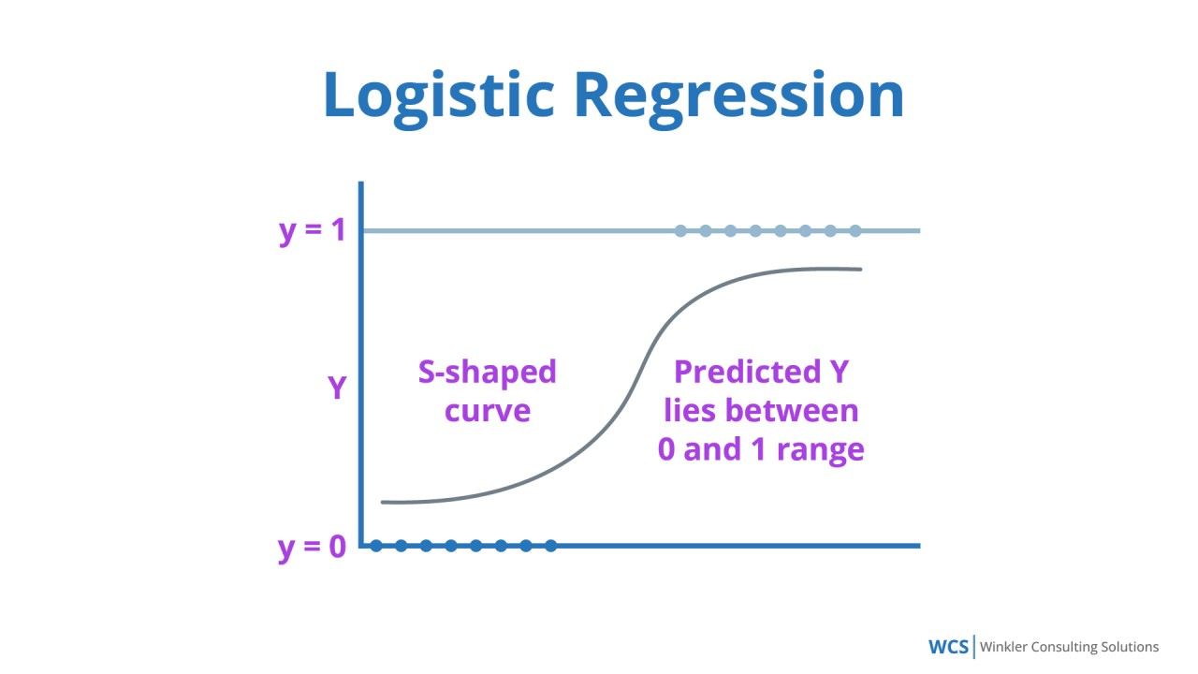

In logistic regression, we use the concept of the threshold value, which defines the probability of either 0 or 1. Such as values above the threshold value tends to 1, and a value below the threshold values tends to 0.

**SIGMOID FUNCTION** is a mathematical function used to map the predicted values to probabilities. It maps any real value into another value within a range of 0 and 1.

The S-form curve is called the Sigmoid function or the logistic function.

**Types of Logistic Regression:**

1. *Binomial*: there can be only two possible types of the dependent variables, such as 0 or 1, Pass or Fail, etc.
2. *Multinomial*: there can be 3 or more possible unordered types of the dependent variable, such as “cat”, “dogs”, or “sheep”.
3. *Ordinal*: there can be 3 or more possible ordered types of dependent variables, such as “low”, “Medium”, or “High”.